Fast**National University of Computer & Emerging Sciences, Karachi  
Summer-2017 CS-Department  
MidTerm 1  
7July 2017, 9:00 am – 10:00 am**

|  |  |  |
| --- | --- | --- |
| **Course Code: CS301** | **Course Name: Theory of Automata** | |
| **Instructor Names: Shaharbano** | | |
| **Student Roll No:** | | **Section No:** |

Instructions :

* Return the question paper.
* Read each question completely before answering it. There are **5 questions and 2 pages**.
* In case of any ambiguity, you may make assumption. But your assumption should not contradict any statement in the question paper.
* Start each question in a new sheet.

**Time**: 60 minutes. **Max Marks** : 50 points

**Question 1: (4+4+1) Points**

**Build the DFA for the language**

1. **L1 = Language upon a and b such that both are even**
2. **L 2= Accepts a language upon 0 and 1 with maximum four ones and any number of zeros.**
3. **Are L1 and L3 a regular Language? Give one statement reason.**

**Question 2: 10 Points**

**Construct the DFA from the given NFA**

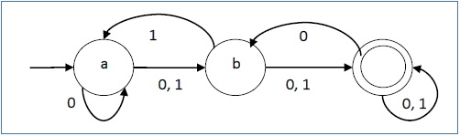

**Question 3: 10 Points**

**Construct the DFA from the given ∈-NFA**

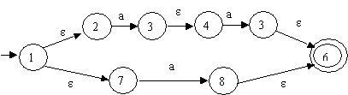

**Question 4: 10 Points**

**Let A = {00, 11} and B = {a, aab, bab}. Find AB and BA. Make a conclusion for AB and BA.**

**Question 5: (5+5) Points**

**Give the full transition table of the following. Check the acceptance/rejection for the string 0101011 using simulation or transitions.**

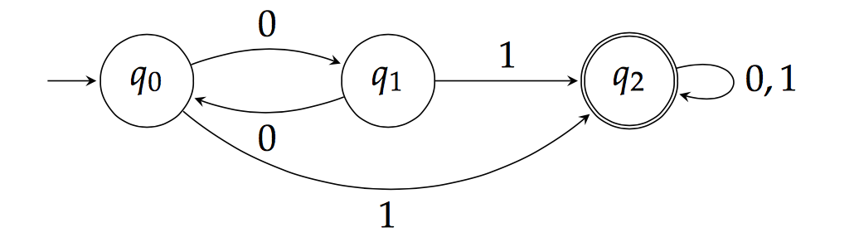

***BEST OF LUCK!***